«Date»

«FIRST_NAME» «LAST_NAME»
«ADDRESS»
«CITY», «PRO» «POSTAL_CODE»

Dear Scouter «FIRST_NAME»,

On behalf of Scouts Canada, we wish to congratulate and celebrate your tremendous achievement of providing «YRS» years of service to Scouting.

Robert Baden-Powell once said, “No one can pass through life, any more than they can pass through a bit of country, without leaving tracks behind, and those tracks may often be helpful to those coming after in finding their way.” Your contributions over these many years have left a path and had a lasting effect on so many people, even when they have moved on to other pursuits. Youth that you served and taught as a Scouter, Volunteers you have worked with; all in turn who have gone on to impact others.

This «YRS» Years of Service Certificate is but a small token of our appreciation and acknowledgement of your exceptional dedication and service to Scouting.

Thank you for your ongoing service to Scouting, and inspiring today's youth through exciting adventures and the Scout Law.

Yours in Scouting,

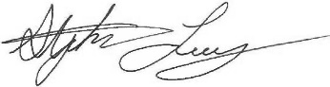 | 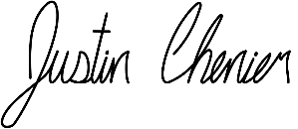 | 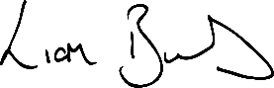
Stephen Loney  National Commissioner | Justin Chenier  National Youth Commissioner | Liam Burns  Executive Commissioner  & CEO

