«Date»

«FIRST_NAME» «LAST_NAME»
«ADDRESS»
«CITY», «PRO» «POSTAL_CODE»

Dear Scouter «FIRST_NAME»,

On behalf of Scouts Canada’s youth and leaders, we wish to personally congratulate you for providing such good service to Scouting for «YRS» years. It truly is a remarkable achievement and something of which you should be very proud!

The «YRS» Years of Service Certificate gratefully acknowledges your very dedicated service to Scouting and your commitment to the Movement itself.

We trust you will continue to grow in the true Spirit of Scouting for many years to come.

Yours in Scouting,

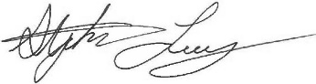 | 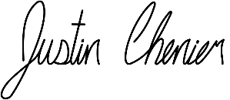 | 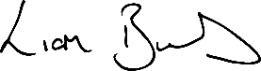
Stephen Loney  National Commissioner | Justin Chenier  National Youth Commissioner | Liam Burns  Executive Commissioner  & CEO

